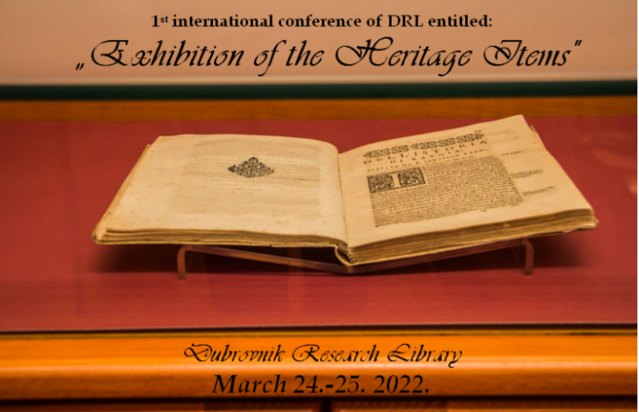
1st International Conference of Dubrovnik Research Library

ANNOUNCEMENT

The Dubrovnik Research Library is organizing 1st International Conference of DRL entitled: „Exhibition of the Heritage Items", which will be held as HYBRID (live and on-line) from March 24th to 25th, 2022, under the auspices of the Ministry of Culture and Media of the Republic of Croatia.

ABOUT THE CONFERENCE

The conference will include a range of presentation formats including papers, posters and panel discussion. The conference will explore best practices in sustainable preventive conservation and risk management approaches to collection care before, during, and after display. New technologies and ideas can lead to qualitative experience improvements for the visitor while maintaining proper conditions for the preservation of the artefacts, although traditional approaches should not be neglected or misrepresented either. The sessions are intended for curators, exhibit designers, preparators, conservators, librarians, archivists, security staff, and any others involved in exhibition planning, design and installation at cultural institutions and considering the long-lasting efforts carried out to protect and preserve our heritage, we would like to have an multidisciplinary approach to the subject and include everyone who played a part in the preservation, monitoring, conservation, protection and promotion of the Heritage.
Participation fee is 50 euro. Participation fee for students is 30 euro
Due to the uncertain situations with the Covid-19 virus pandemic, the conference will will be held as HYBRID (live and on-line) from March 24-25th, 2022.
Working language is English.
Time zone: Europe/Zagreb - UTC+1 hour
WEBSITE: www.drlconference.dkd.hr

INVITED SPEAKERS

Jeanne Drewes, Retired as the Chief of Binding and Collections Care in the Preservation Directorate at the Library of Congress, United States
Matija Strlic, Deputy Director of UCL Institute for Sustainable Heritage, United Kingdom
Valentina Ljubic Tobisch, Freelancer conservator and consultant in the field of conservation and restoration as well as museological and preventive conservation tasks, Austria
Iva Gobić-Vitolović, Head of the Conservation and Restoration Department at the State Archives in Rijeka, Croatia
Roger S. Wieck, Melvin R. Seiden Curator and Department Head of Medieval and Renaissance Manuscripts at the Morgan Library & Museum in New York, United States
Rasha A. Shaheen, Senior Photographs and Paper Conservator at The Egyptian Museum, Cairo, Egypt

TOPICS & CALL FOR PAPERS

The main topic is „Exhibition of the Heritage Items“, which includes exploration of best practices in sustainable preventive conservation and risk management approaches to collection care before, during, and after display.

Materials: Art and cultural artifacts in libraries, archives, museums and galleries

The papers should be primarily focused on the following topics:
- Assessing display requirements
- Incorporating preservation and security into the exhibition process
- Providing interactive experiences
- Conservation-restoration for exhibition
- Experiences with travelling exhibitions
- Sustainable exhibit design
- Experiences with travelling exhibitions
- Sustainable exhibit design

The deadline to submit your abstract is extended to January 7th, 2022

We invite local and international colleagues and interested professionals to submit scientific or professional paper abstract until January, 7th 2022

Authors can submit the following:
- Summary (up to 500 words, keywords);
- Poster (1 - 2 pages, graphic or textual presentation of selected topics);

Scientific Commitee

Dr. Dragica Krstić, National and University library of Zagreb
doc. art. Sanja Serhatlić, University in Dubrovnik, Department for Art and Restoration
Dr. Denis Vokić, University in Dubrovnik, Department for Art and Restoration
Dr. Jasna Malešič, National and University Library of Slovenia
Mgr.art. Barbara Davidson, ArtD. .Member of the Committee of E.C.C.O., City Gallery of Bratislava

Important dates:

-Receiving Abstracts – January, 7th 2022
-Notice of accepting the abstract - January 31st, 2022
-Receipt of complete works - February 27th 2022
-Beginning of conference - March 24-25th 2022
For all questions please email us at: drlconference@dkd.hr

